St. Oswald’s Church of England Academy
Addison Road, Rugby, Warwickshire, CV22 7DJ
Tel: 01788 543882

Headteacher: Mrs. J. Geran


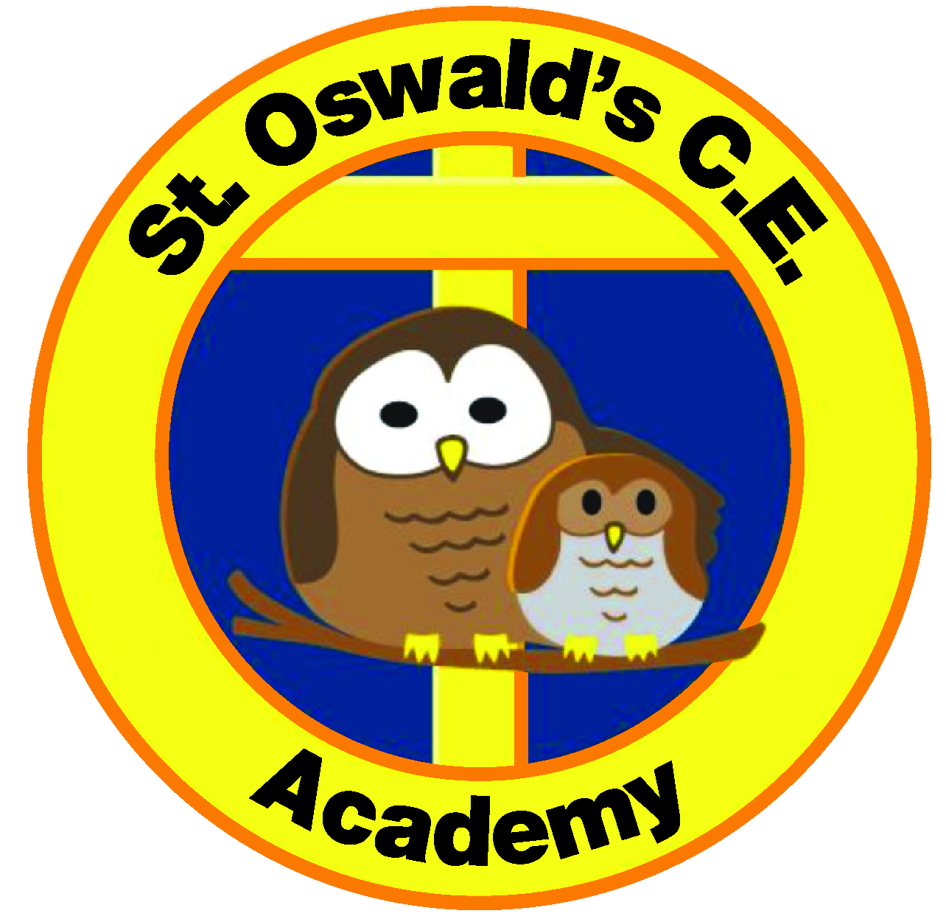

E-Mail: school.office@stoswalds.covmat.org Website: www.stoswalds.covmat.org
Facebook: www.facebook.com/StOswaldsCEAcademy

Basis of charging and fee structure at St Oswald’s CofE Academy Nursery
The basis of charging at St Oswald’s CofE Academy Nursery is in line with the Early Education and Childcare Statutory guidance April 2024 and is compliant with the Department for Education revised statutory guidance April 2025.
Universal nursery education funding is available for all children from the term after their 3rd Birthday providing they turn 3 before the end of March, August or December. You will then be entitled to receive nursery funding for up to 15 hours per week 38 weeks per year in a nursery of your choice. Depending on eligibility, some parents may be entitled to an additional 15 funded hours per week.
Parents will need to apply for any additional funding the term before they intend to use it in a childcare setting through the ‘Best start in life’ website where parents/carers can also check their eligibility and the funding they are entitled to.
https://beststartinlife.gov.uk/childcare-early-years-education/
Additional funding:
Some children may be eligible for additional funding to support their learning and development. Early Years Pupil Premium (EYPP) provides extra funding and support for children from eligible families, while the Disability Access Fund (DAF) supports children with disabilities by helping settings make reasonable adjustments or provide additional resources. These payments are made directly to the childcare provider and do not affect any benefits you may be in receipt of. For more information, please visit:
https://www.gov.uk/get-extra-early-years-funding
If your child attends more than 30 hours in total, whether in one or more childcare settings, there will be an additional charge. St Oswald’s CofE Academy Nursery currently charges any child that is not eligible for Government funding. This charge is set by the school and governers.
Should you have any queries with regards to funding and entitlements, please contact either Rachel Greer the EY Lead or Danielle Pritchard the funding administrator who will be happy to help.

Fee Models at St Oswald’s CofE Academy
St Oswald’s CofE Academy Nursery is open from 8:45am-3pm Monday-Friday 38 weeks per year excluding Bank holidays. There is no minimum session requirement for children to attend our Nursery.
Session | Cost  (Where child is not eligible for government funding) | Cost of Session using universal or extended funding
Morning Session  8:45-11:45am | £18 | Free (3 hours of Government funding used for this session)
Hot Lunch | £2.75  (Prices set by caterlink) | £2.75  (Hot lunches are not covered by Government funding)
Afternoon Session  12pm – 3pm | £18 | Free (3 hours of Government funding used for this session)
Short Afternoon Session  11:45am – 1:30pm | £9 | n/a
Full day session with a hot lunch  8:45am – 3pm | £38.75 | £2.75  (6 hours of Government funding used for the session)
Full day session with a packed lunch  8.45 – 3pm | £36 | Free  (6 hours of Government funding used for the session)

Bookings for ad hoc/set sessions
At St Oswald’s CofE Academy Nursery we recognise on occasion parent’s may require additional session bookings such as an afternoon session or short afternoon session. If additional costed sessions are required in addition to universal 15-hour entitlement these need discussion and confirmation with the EY lead at the earliest opportunity with at least 7 days prior to your child’s additional session date. Where possible we will seek to accommodate however at times due to ratio requirements it may not be possible.

